# INTRODUCTION:

1**.Overview:**

An EV is a shortened acronym for an electric vehicle.EVs are vehicle that are either partially or fully powered on electric power.Electric vehicles have low running costs as they have less moving parts for maintaining and also very environmentally friendly as they use little or no fossil fuels(petrol or diesel).

The first electric car in the IUnited States was developed in 1890-91 by WILLIAM MORRISON of Des Moines,lowa; the vehicle was a six-passenger wagon capable of reaching a speed of 23 kilometers per hour (14 mph).

2.**Purpose:**

Electric vehicle using BEV technology run entirely on a battery powered electric drivetrain.The electricity used to drive the vehicle is stored in a large battery pack which can be chared by plugging into the electricity grid.

Vehicle power electronics primarily process and control the flow of electric vehicle,including plug in electric vehicles.They also control the speed of the motor,and the torqueit produces

1. **Problem Definition & Design Thinking**

1.**Empathy map:**

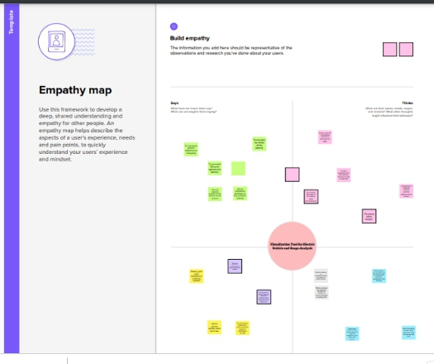

**2.Ideation & Brainstorming Map**

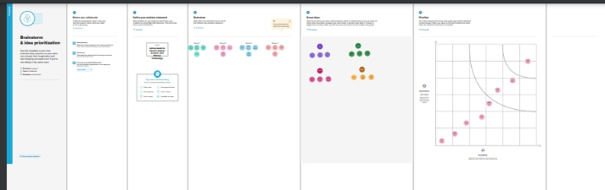

# RESULT:

# 

# 

# 

# 

# 

4.Advantages:

**\*** No fuel required so you save money on gas.

**\***Environmental friendly as they do not emit pollutants.

**\***Lower maintenance due to an efficient electric vehicle.

**\***Better Performnce.

**\***It is a clean,safe,cheap,and convenient source of Energy.

Disadvantages:

**\***Higher purchase cost.Compared to regular automobiles.

**\***Low speed and range.

**\***The inconvenience of service station.

**\***Expensive Recharging Options.

**\***Charging infrastructure worries.

5. Applications:

# Copper is an essential material component of electric vehicles. It is used in the electric motors, batteries,inverters, wiring and in charging.

# Electric vehicle use electricity to charge their batteries instead of using fossil fuels like petrol or diesel.Electric vehicles are more efficient.Electric vehicle is cheaper than filling petrol or diesel for your travel requirements.

# 6. Conclusion:

Electric vehicles (EVs) are a promising technology for achieving a sustainable transport sector in the future, due to their very low to zero carbon emissions, low noise, high efficiency, and flexibility in grid operation and integration. This chapter includes an overview of electric vehicle technologies as well as associated energy storage systems and charging mechanisms.

# 7.Future Scope:

.

The EV industry in India can create some 10 million or 1 crore direct jobs and 50 million or 5 crore indirect jobs by 2030, according to estimates by the Ministry of Skill Development and Entrepreneurship.By 2030, about 40-45% of all two-wheelers (2W) and 15-20% of all four-wheelers (passenger vehicles) sold in India will be electric

.